3 Tire Architecture (Web>App>DB)

- Created Web01 and installed (Nginx) into it and Nsg(source:Any, Dest:App01, DPort:80) and (SSH:22)
- Next App01 installed (Tomcat)
- Allow port from Source:Web01(private Ip), Dest:APP01(Private Ip),Dport:8080

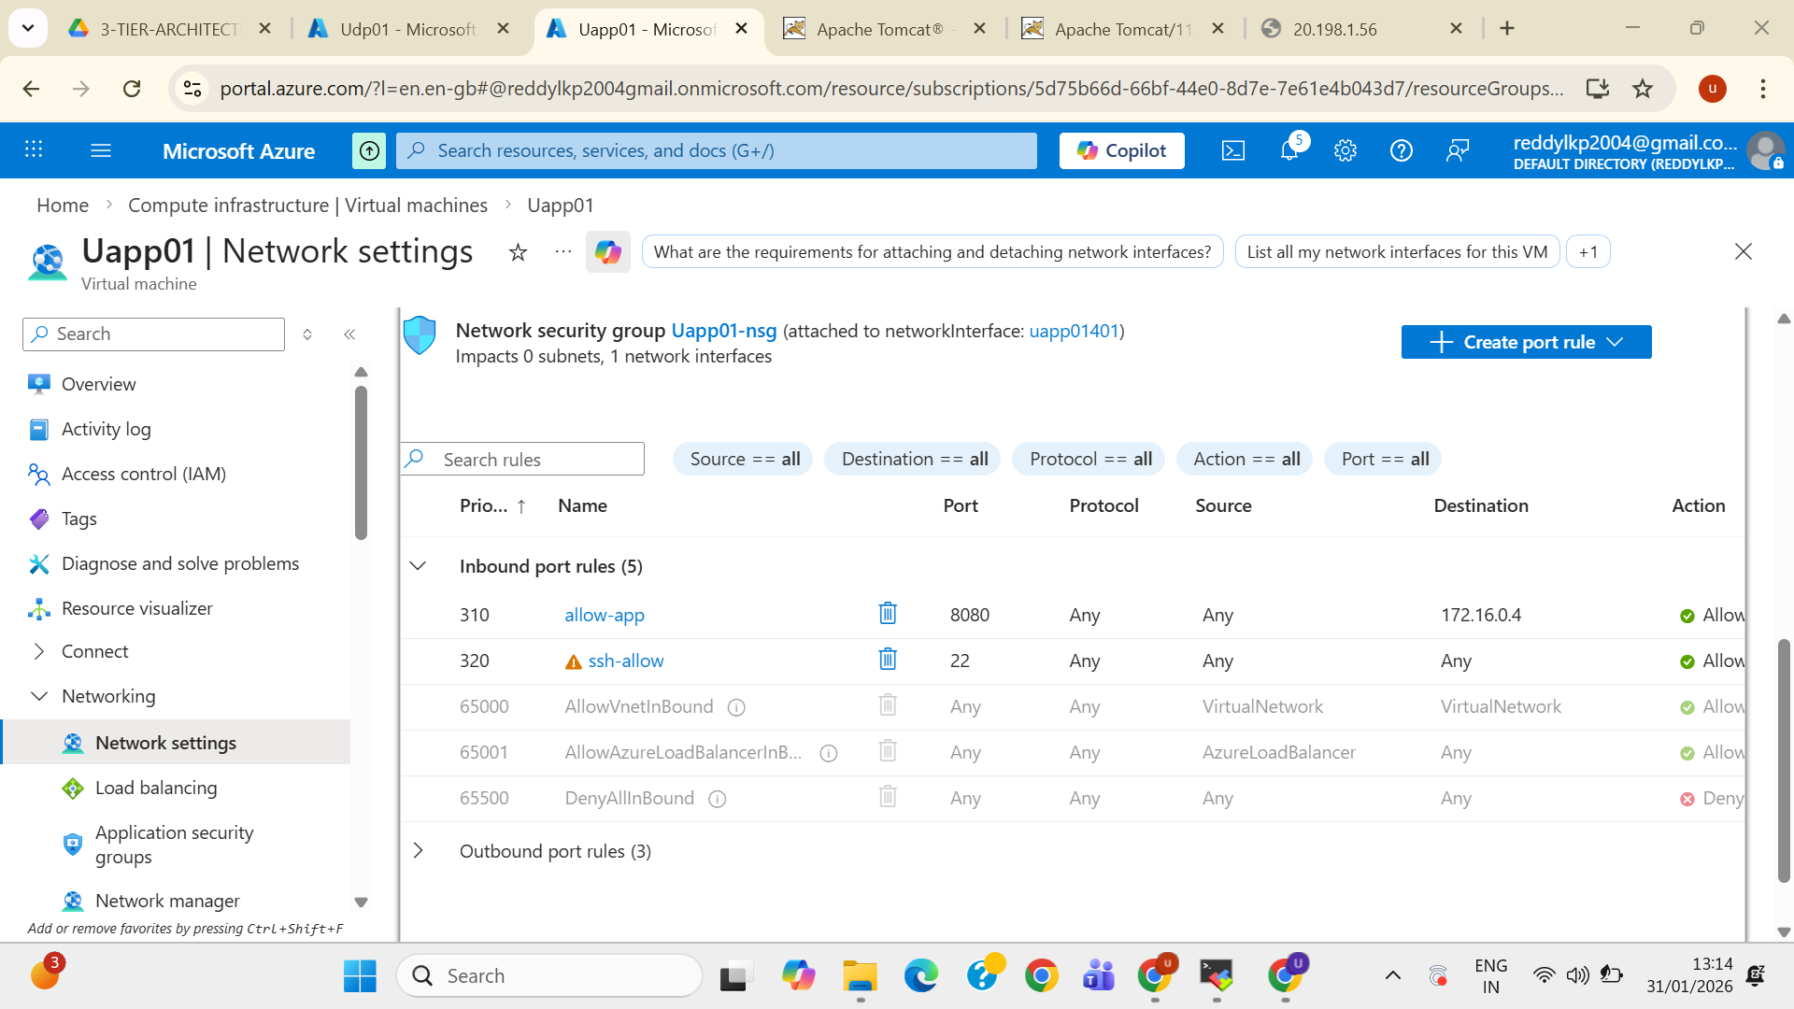
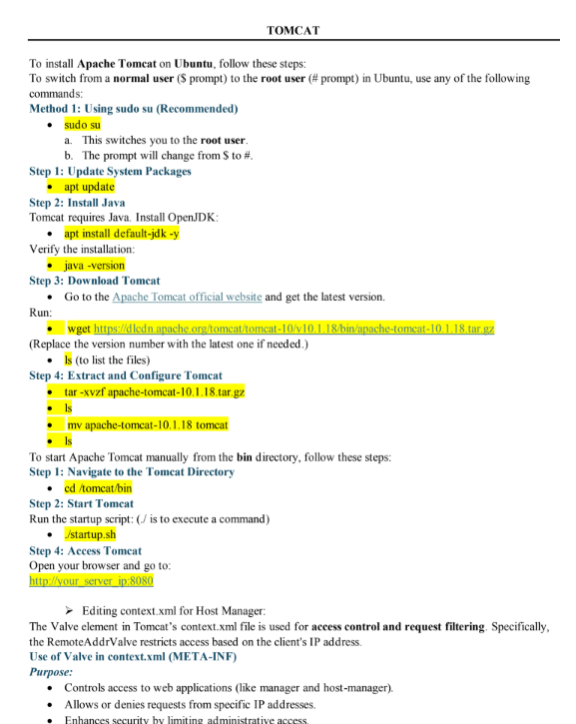

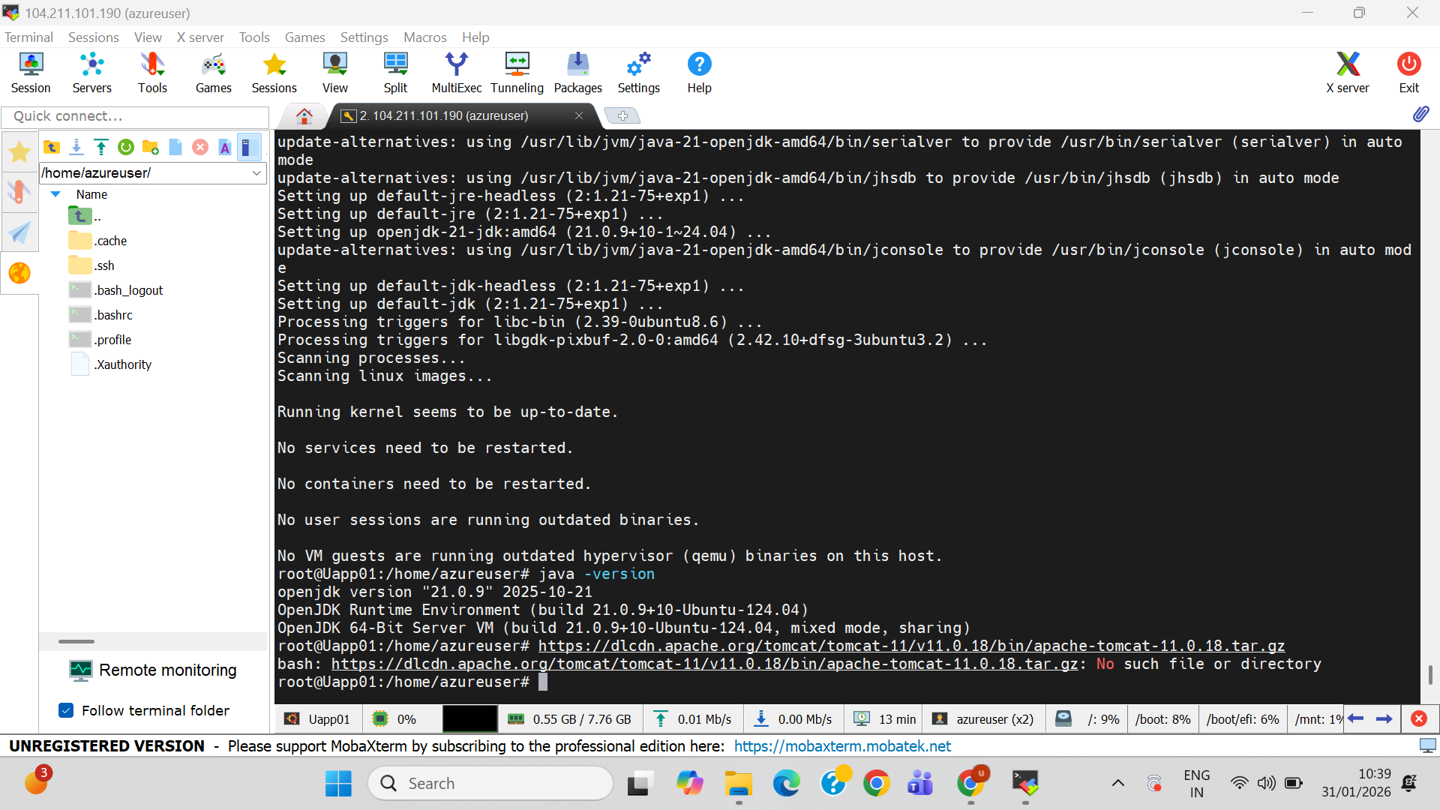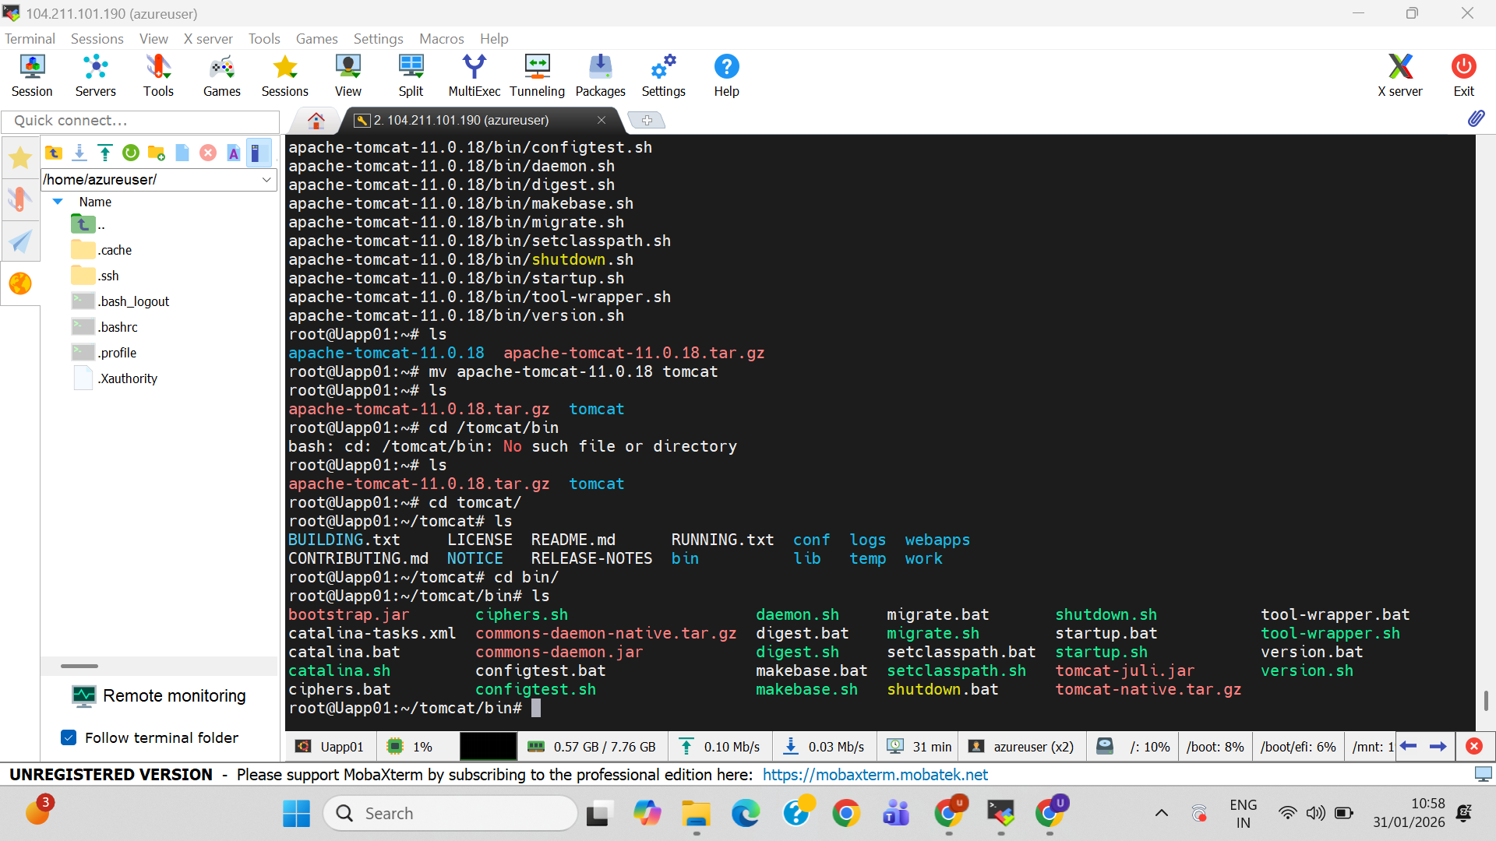
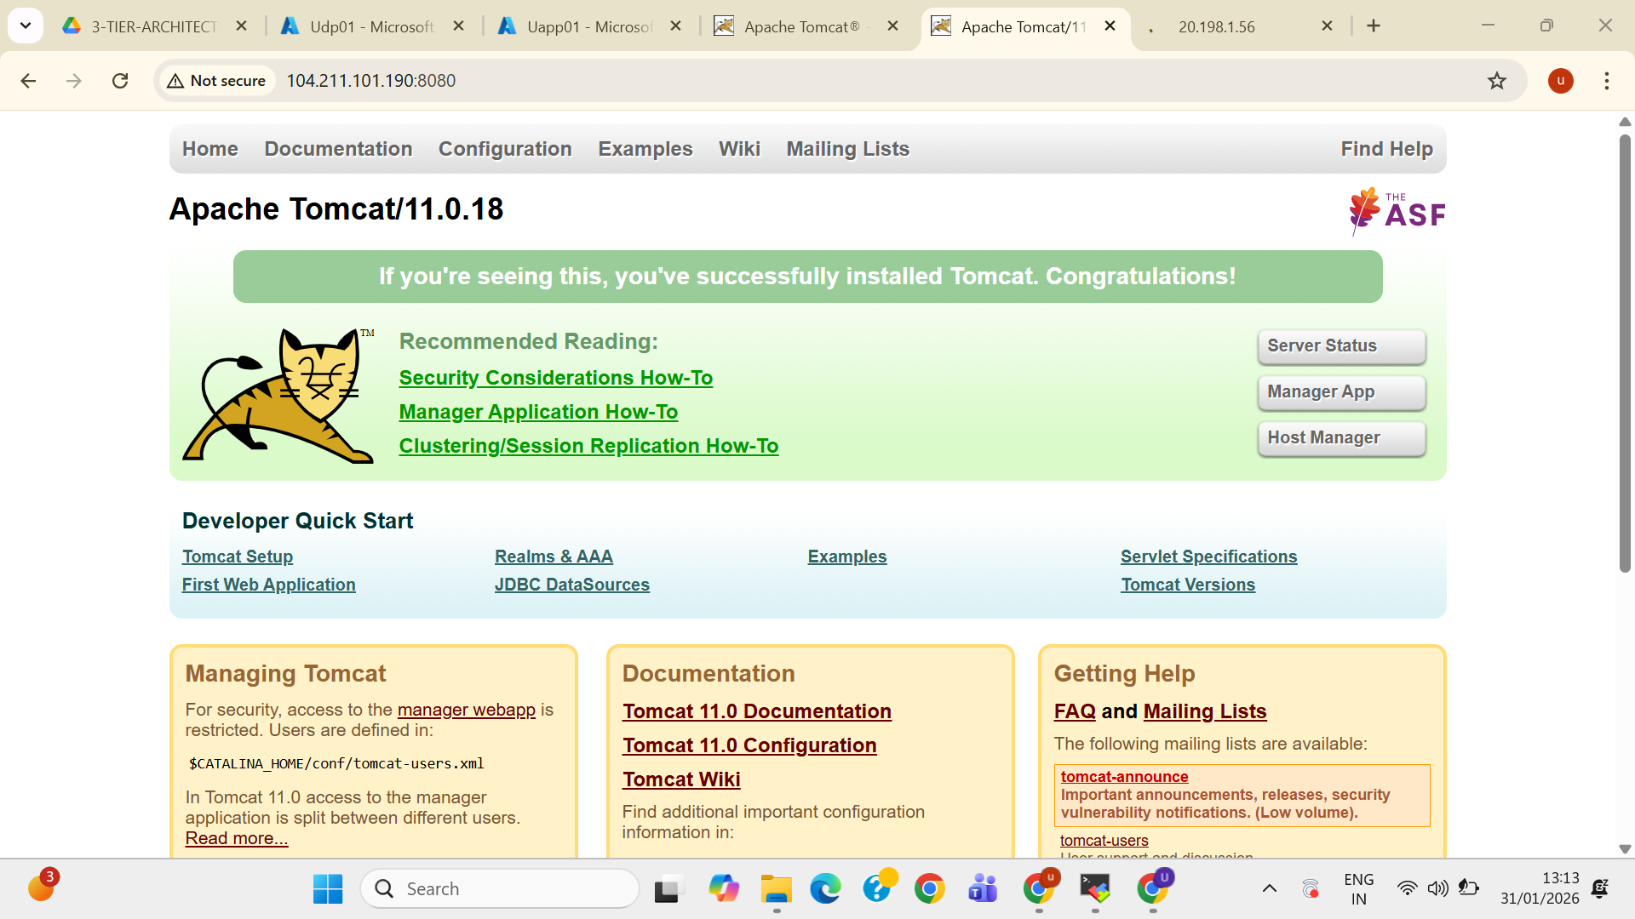

- Next DB01 Install (Mysqldb)
- Allow port from Source:App01(private Ip), Dest:DB01(Private Ip),Dport:3306

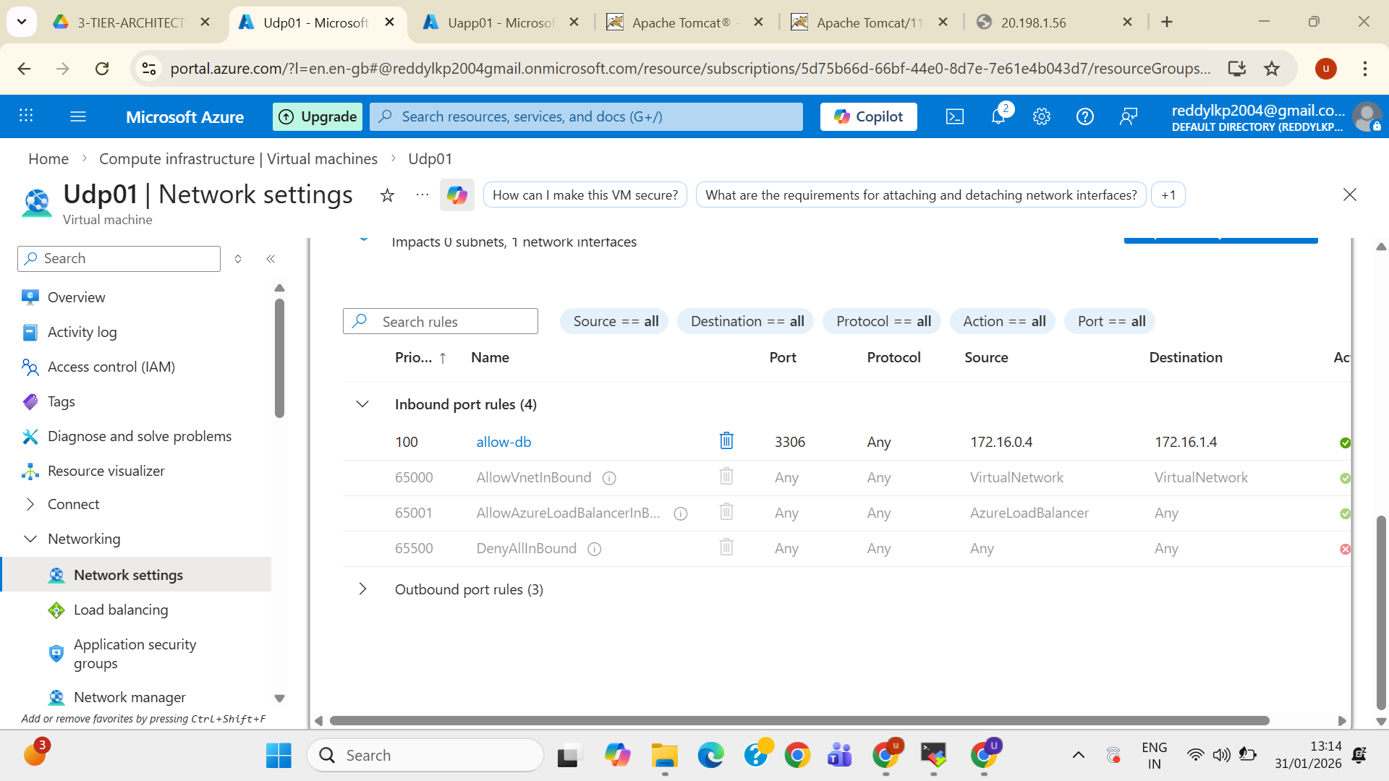

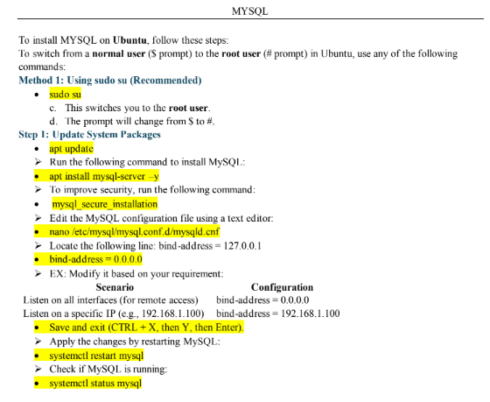

After installing mysql on DB, Edit the file which is stored inside /etc/mysql/mysql.conf.d/mysqld.cnf ---This is the file we have to edit,In side file there is a bind-address it should be 0.0.0.0,
bind-address = 0.0.0.0 and save & Exit.

- Now see connection from Appo1 to DB01 with the help of Telnet DB(private ip) (3306) from App0, Because DB we cant browse on internet, That’s way we should connect from App to DB. Status should be Connected.
- Next configure Denny access from Web01 to DB01,
- No-direct Connection b/w them
